**REBATES!                   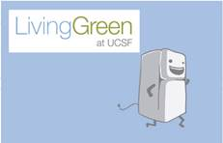**

**$400 Cash-Back rebates for Refrigerator/ Freezers**

**$450 for -20C Freezers and**

**$5000 for -80C Freezers!**

**Act Fast! Extended until October 31, 2014**

Replace your **old inefficient refrigerators and freezers** with a newer efficient model.   Contact [Sustainability@ucsf.edu](mailto:Sustainability@ucsf.edu)

Choose Retirement of your **freezers, refrigerators**, or **fume hoods** and get a cash incentive!  Contact [James.Hand@ucsf.edu](mailto:James.Hand@ucsf.edu)

Switch out your space heater for a **free feet warmer**. Contact [James.Hand@ucsf.edu](mailto:James.Hand@ucsf.edu)

**Offer good through until the funds are exhausted.**

**Questions? Contact UCSF Sustainability Coordinator, Julianne Richter at 415-502-9393.**